In-Class Exercise Responsive

**Objectives:**

Demonstrate Understanding of:

1. Layout options
2. Working with mobile-first designs
3. Writing media queries

**Deliverables**:

It is not expected that you will complete this in-class exercise during lecture time. However, when you are complete you should an exact replica of the screenshots provided. Host your site and submit the URL to Canvas.

**Steps:**

**Part One: Preparation**

1. Form a team of 2 - 3 students.
2. Check out the partial code for ICE-Responsive. It can be found at the course GitHub repository (<https://github.com/cvanlent/WebDesign2018/tree/master/ICE>).
3. View the site on a screen size of < 850px - it should match the following screenshots other than you need to fix the navigation on the mobile view to show the current page.

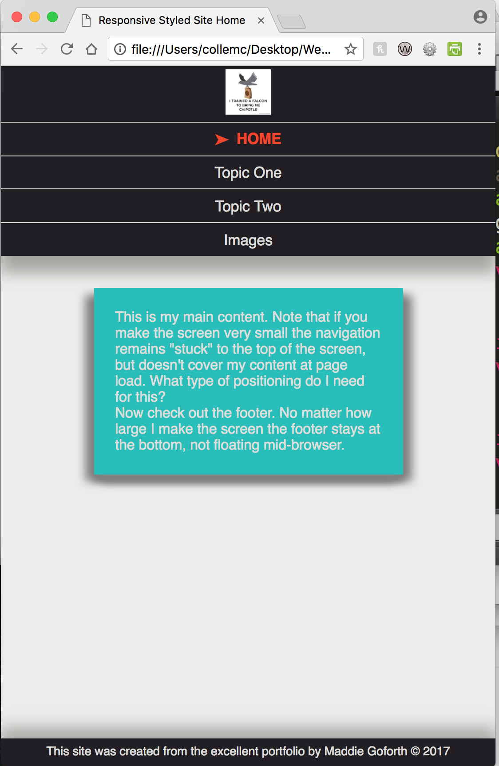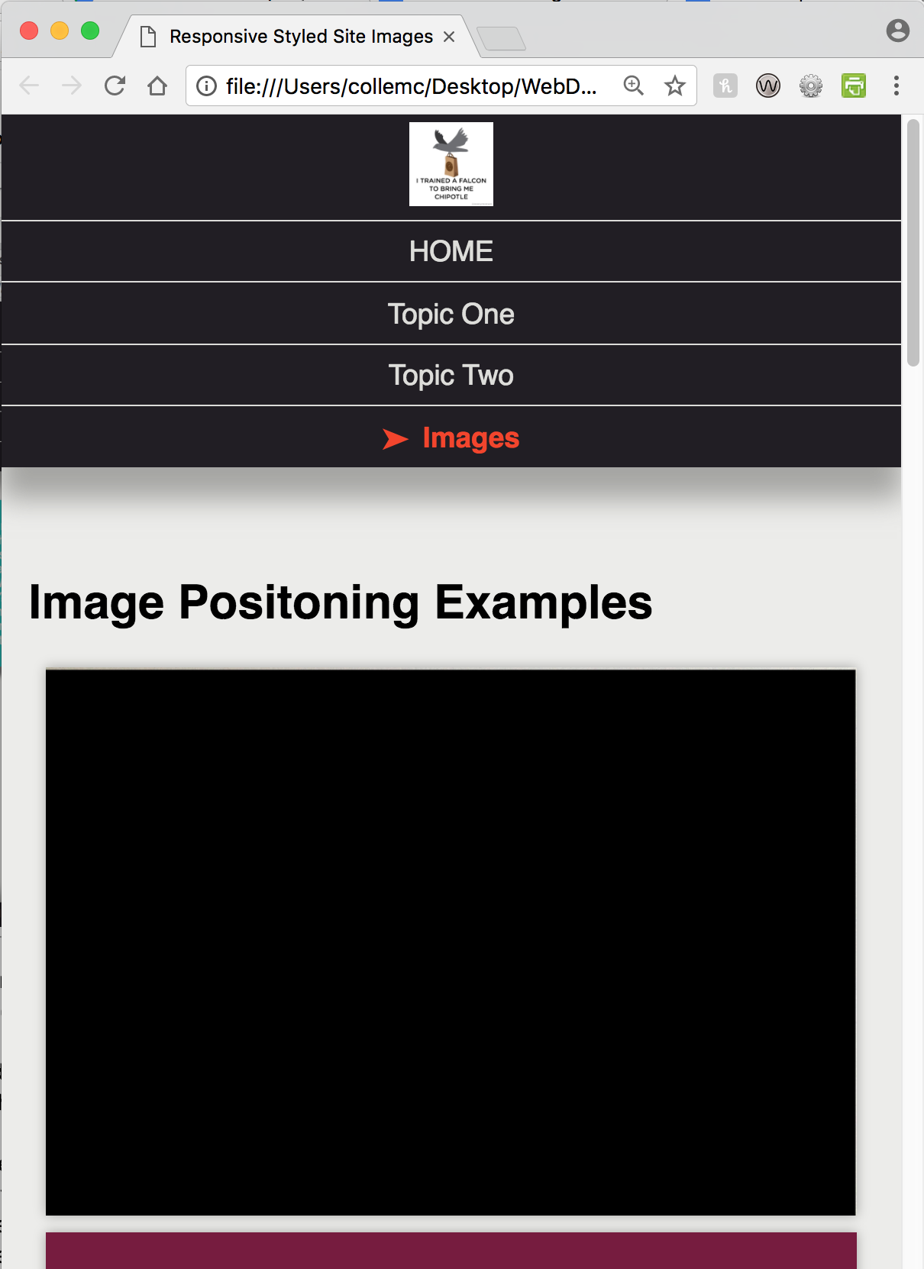

**Part Two: Screen Over 650px**

1. Create a new stylesheet that will style your page for a midsize view of over 650px. (You can change the HTML as well if needed.)
2. Your new page should update the navigation and image layout as shown here:

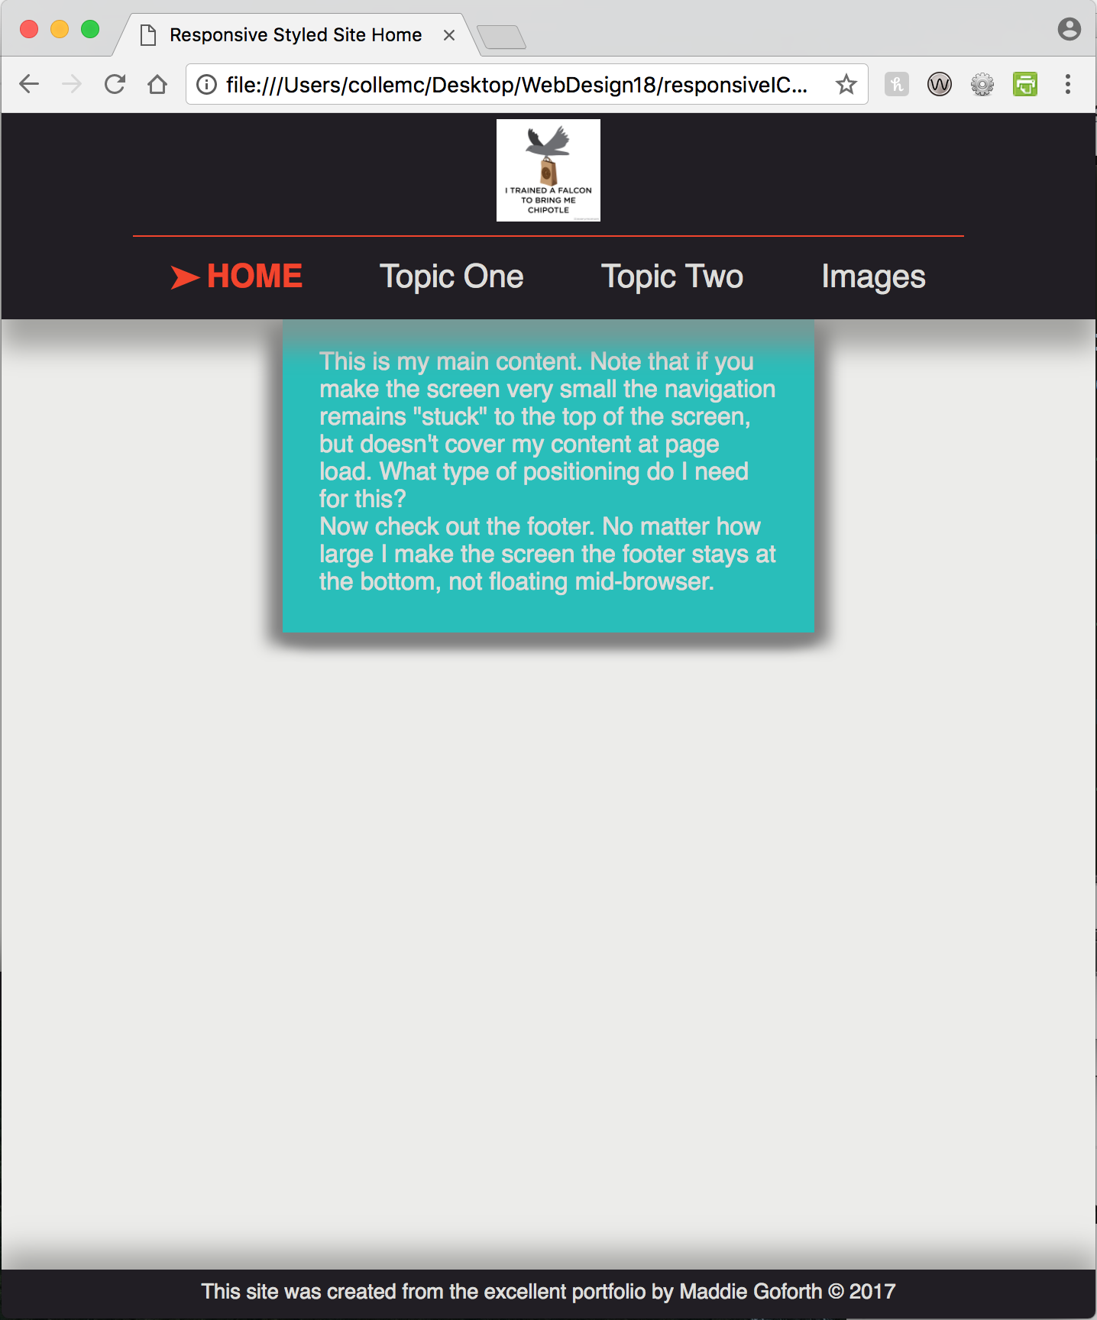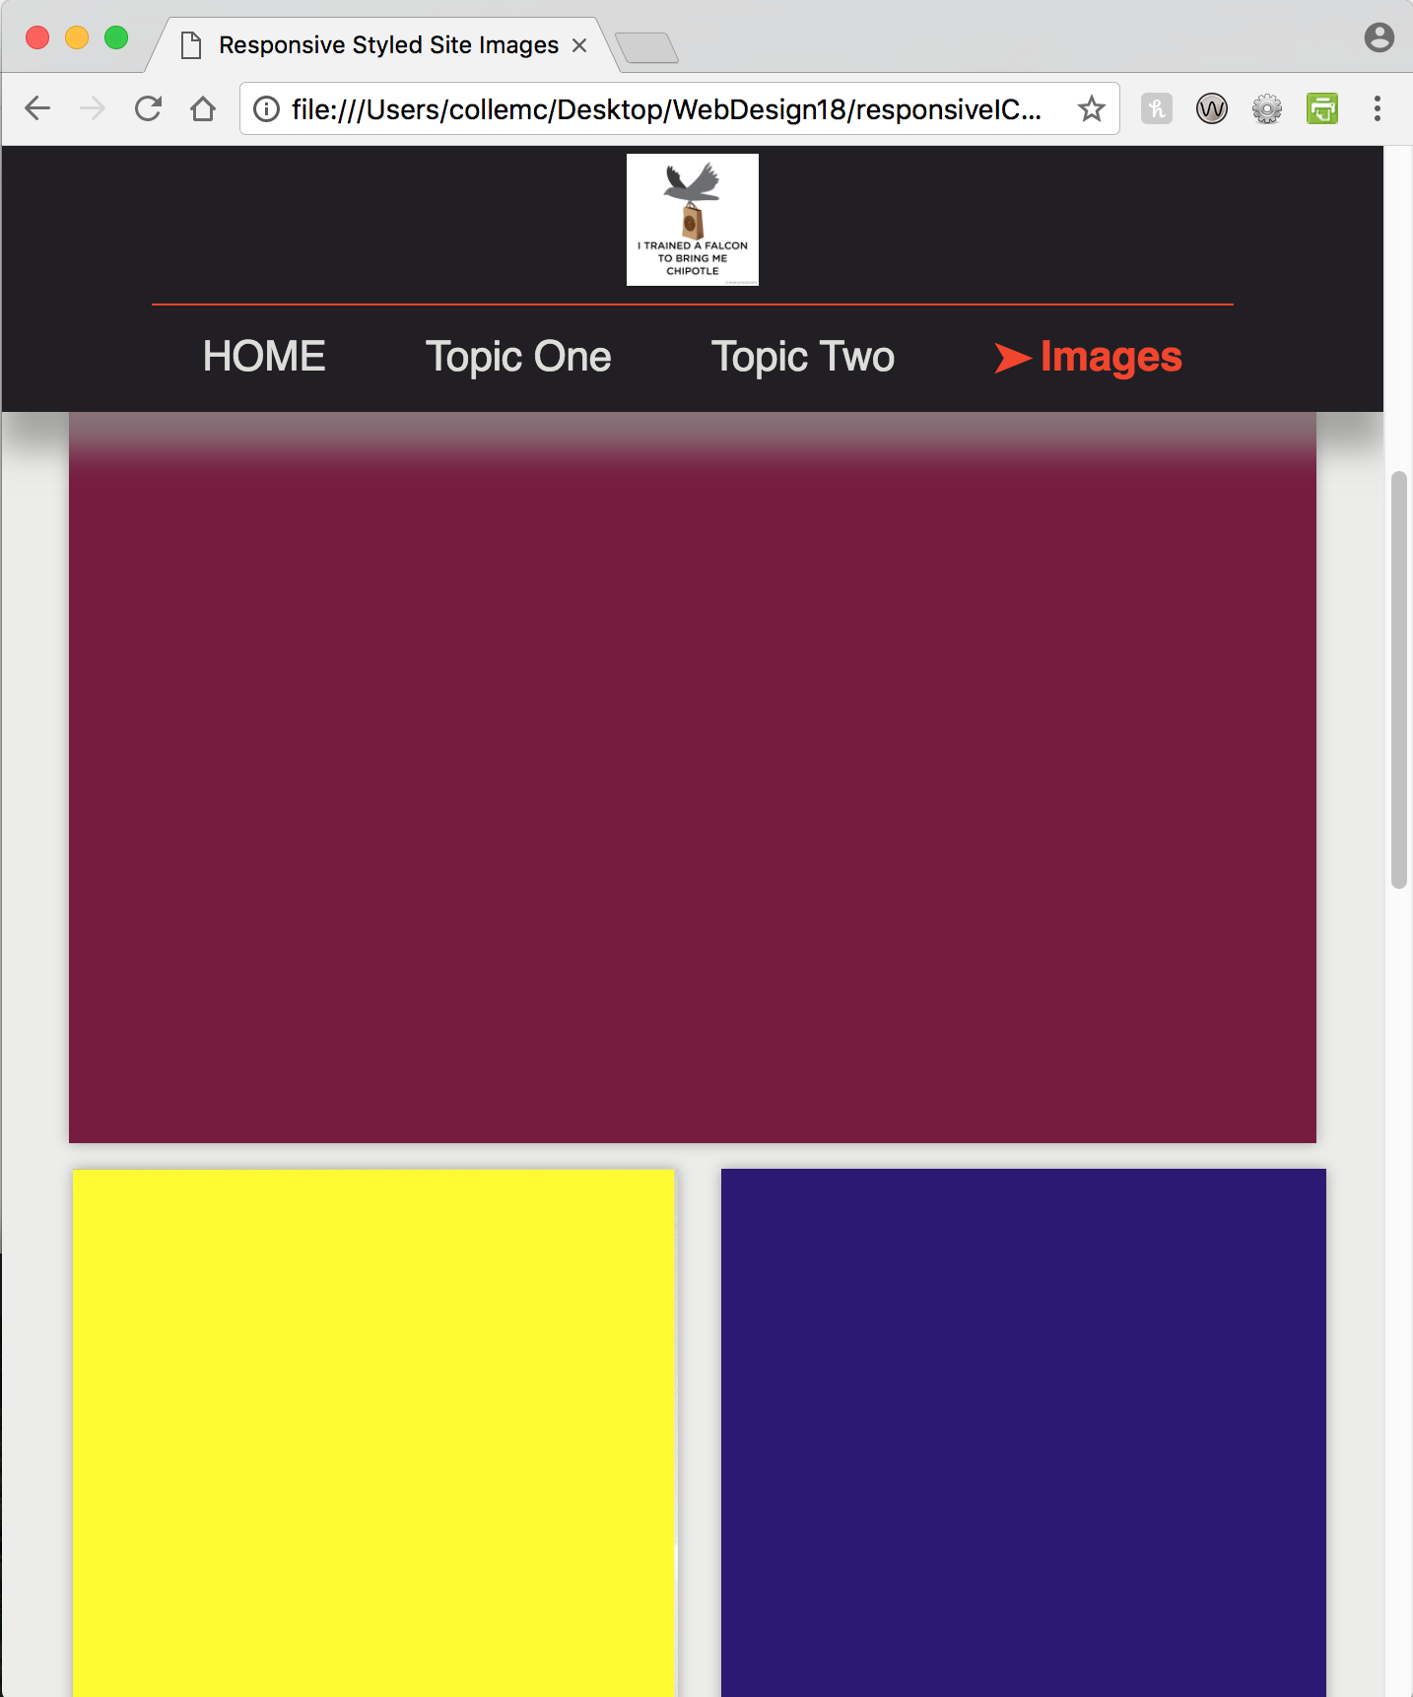

**Part Three: Screen Over 1000px**

1. Modify the a new stylesheet that will style your page for a midsize view of over 100px. (You can change the HTML as well if needed.)
2. Your new page should update the navigation and image layout as shown here:
3. 